|  |  |
| --- | --- |
| garment inventory system |  |
|  |  |
| 3/17/2014 | Group 5 |
| Course no: CSE 308 | **Student id: 1005047,**  **1005051,**  **1005053,**  **1005056 &**  **10050 57** |

garment inventory system

Group 5

GRAPHICAL USER INTERFACE DESIGNS

Welcome screen for the system

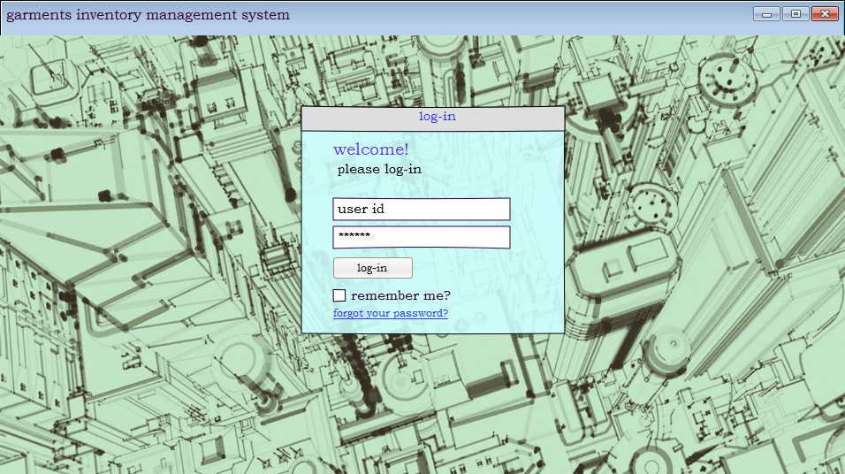

If the log-in is successful, then this page will be displayed

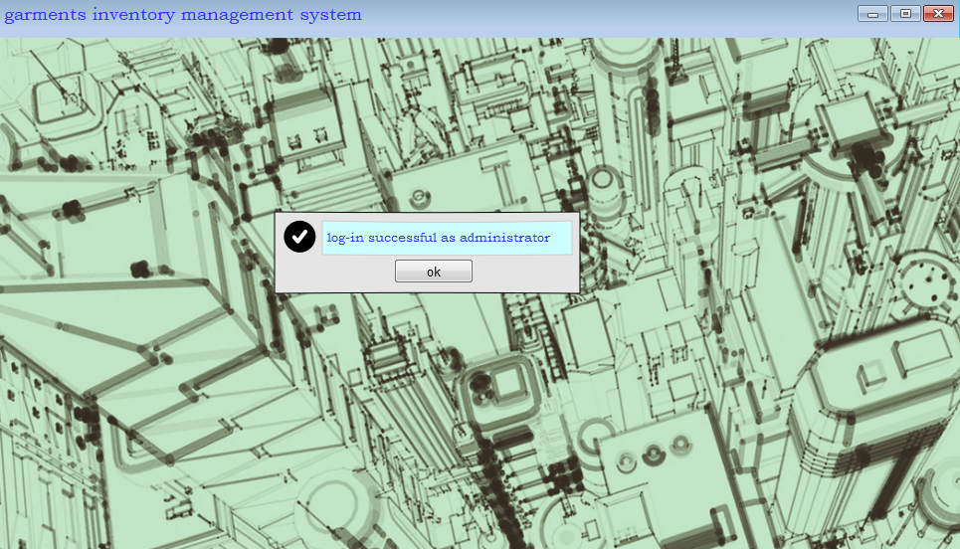

System will detect the user by his/her employee id and show the appropriate message. This page is different for different type of users.

If the log-in is unsuccessful, then this message will appear.  
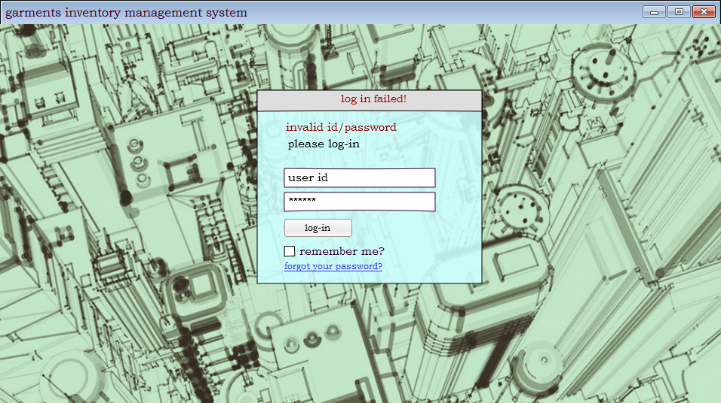

If the user clicks ‘forgot your password’

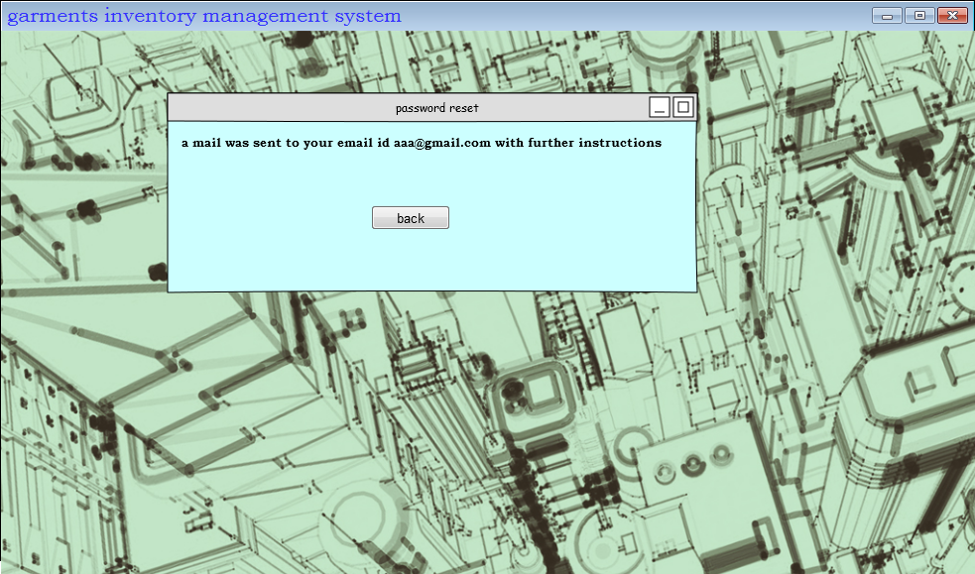

If the user is from main office, i.e. the head of the office then this is the menu screen  
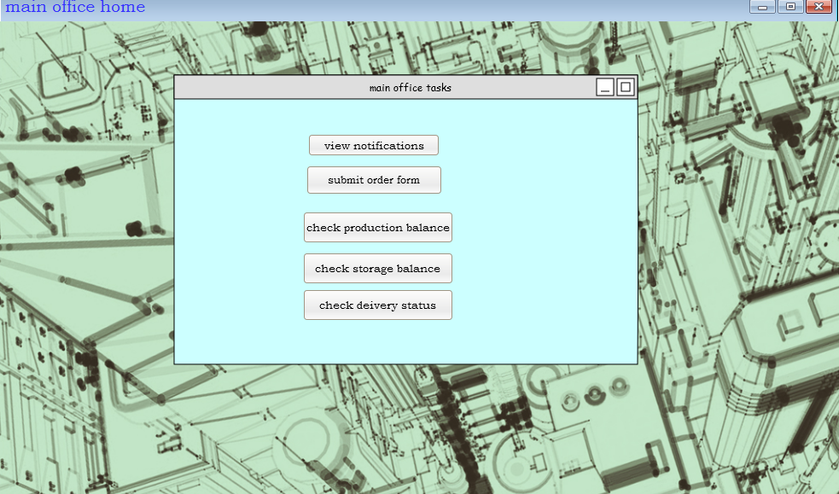

The check production balance option:

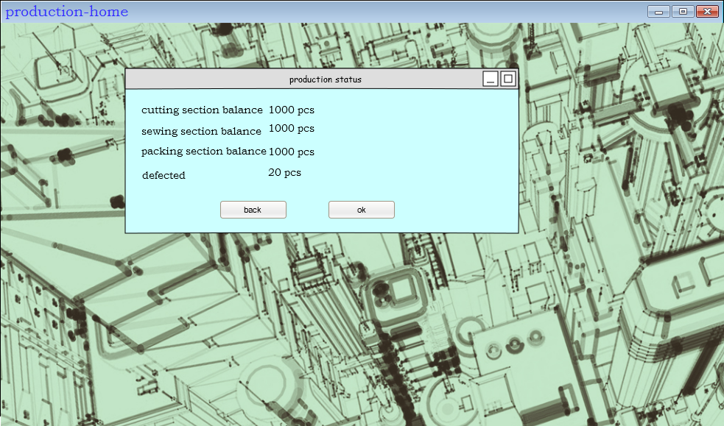

Check storage balance option:

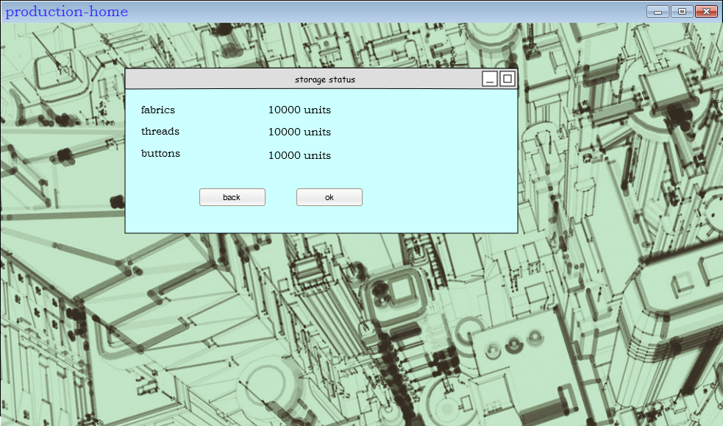

Check delivery status option:

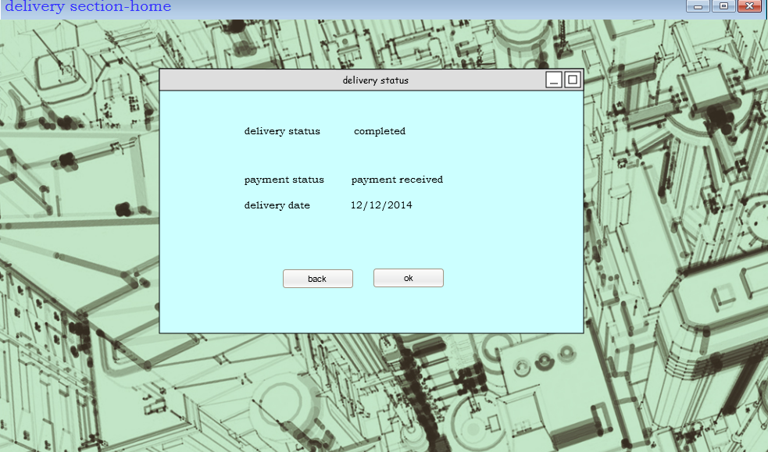

If he selects submit order form option   
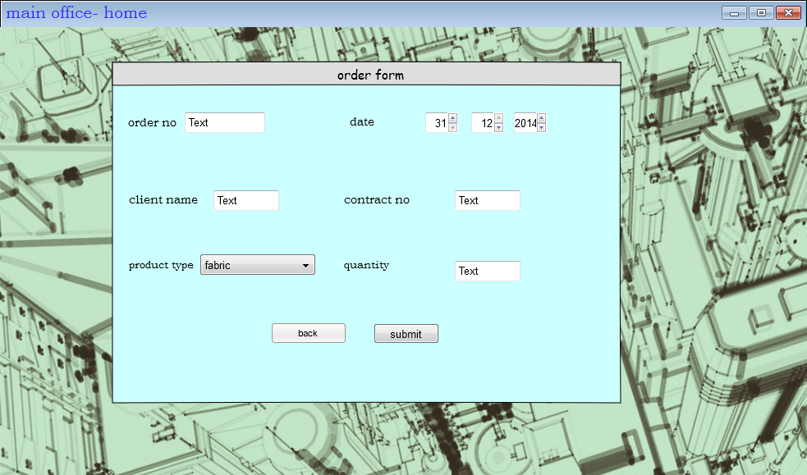

if the order form is submitted successfully,then this message will be displayed  
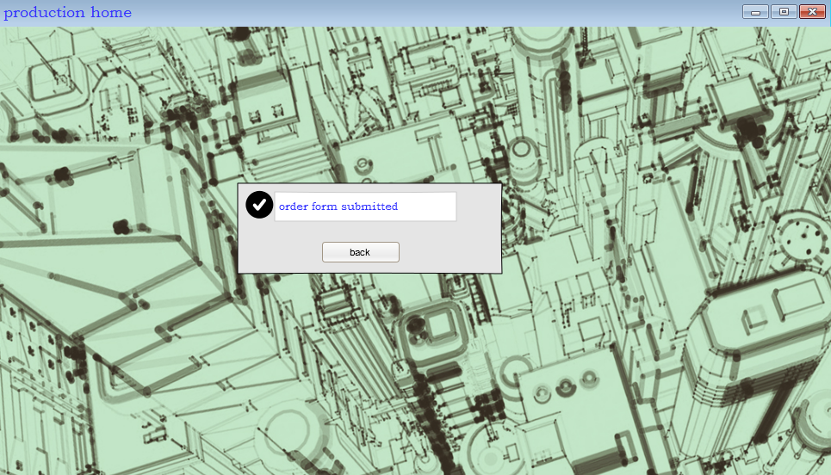

if the user

if the user is storage worker:  
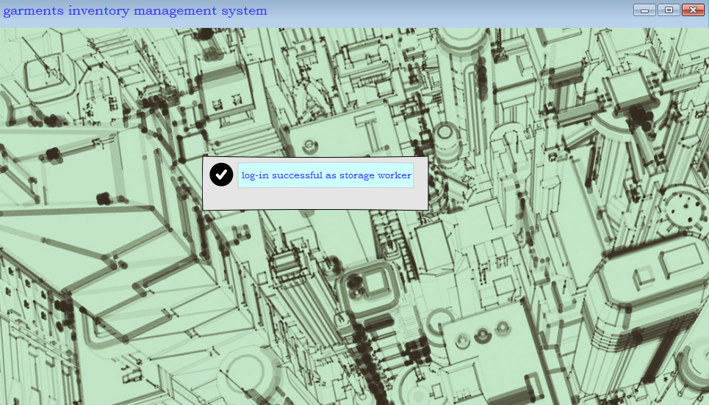

the storage menu:  
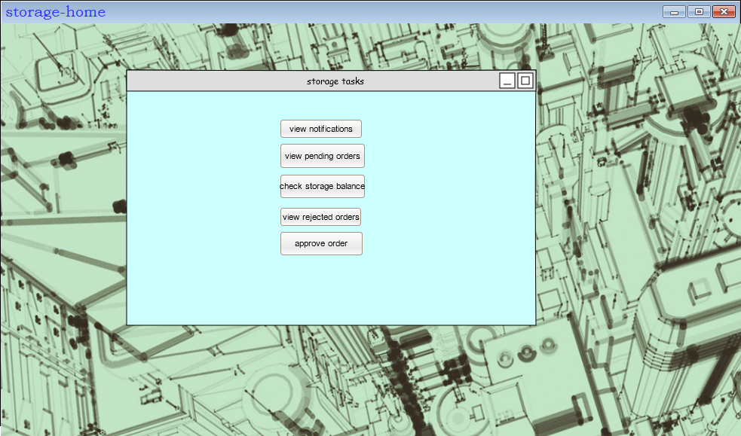

if the user selects view pending orders:

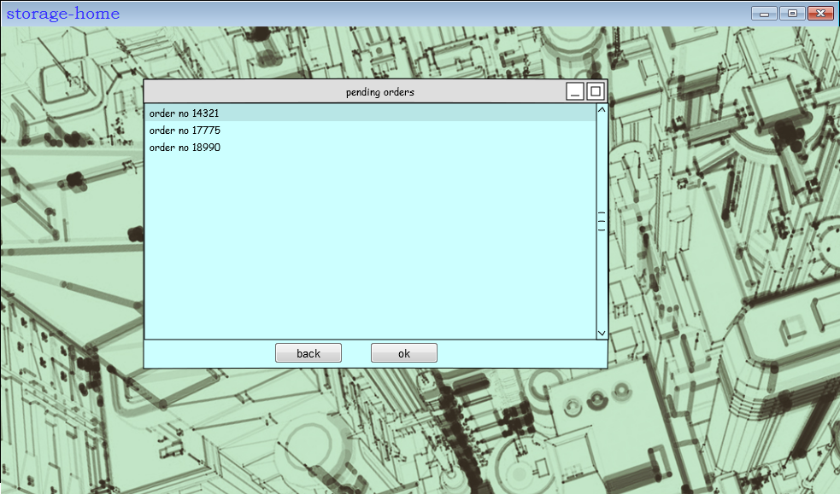  
  
after he selects a form:

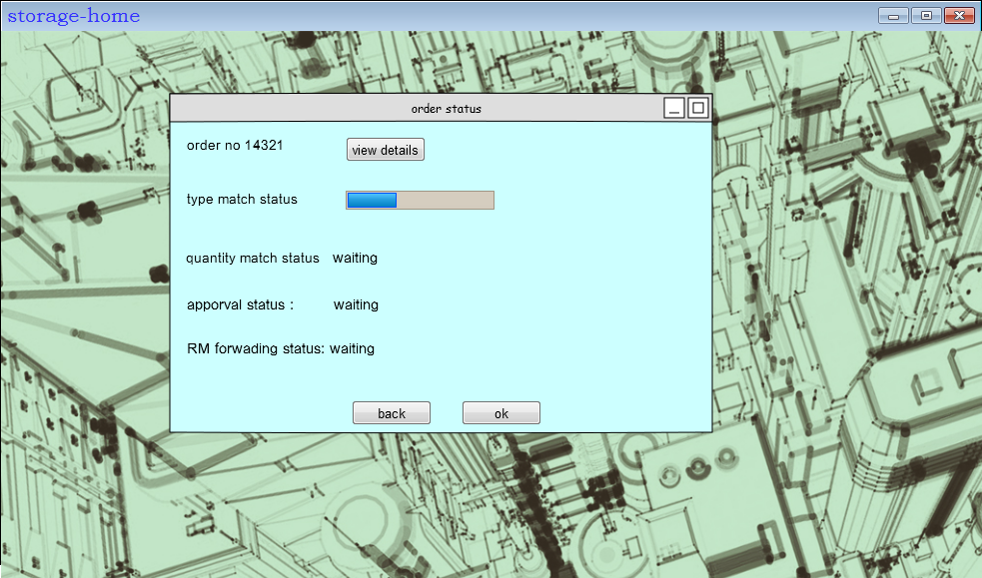

If match type is successful: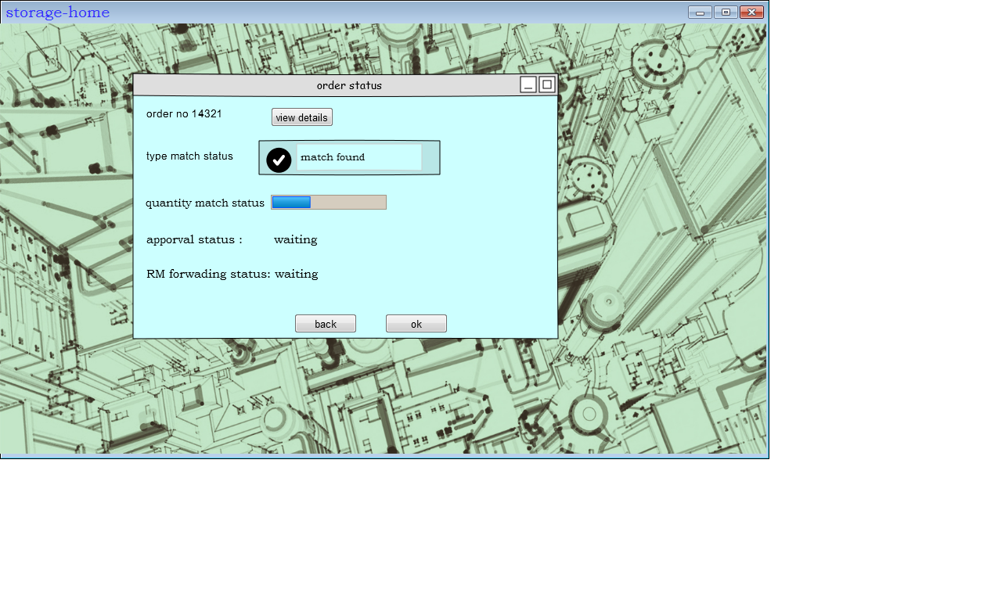  
if match type is not successful:

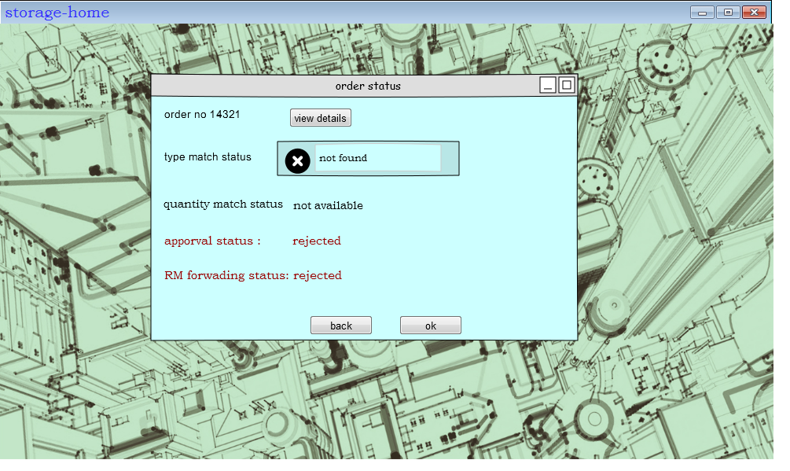

If match quantity is successful:

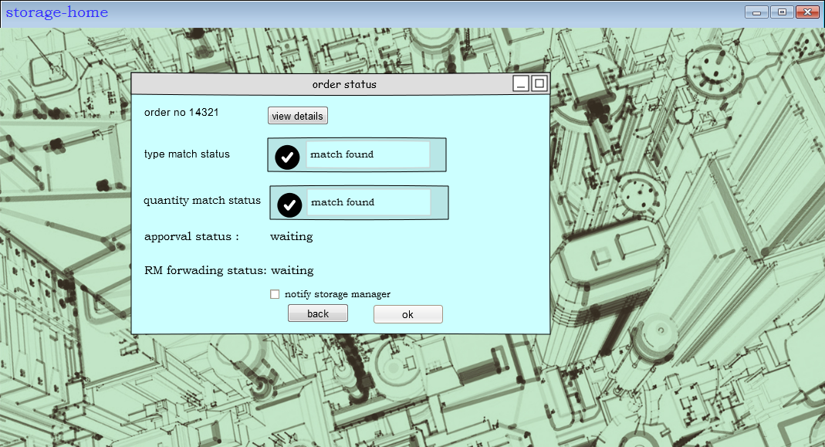

Match quantity not successful

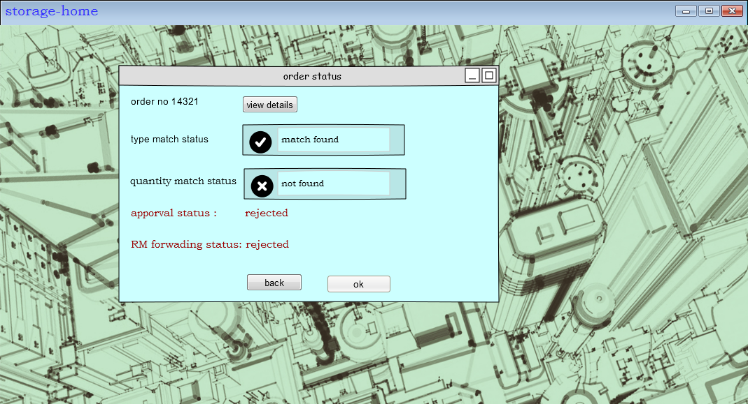

If the user is logged in as storage manager, and he clicks the view notifications button in main menu  
  
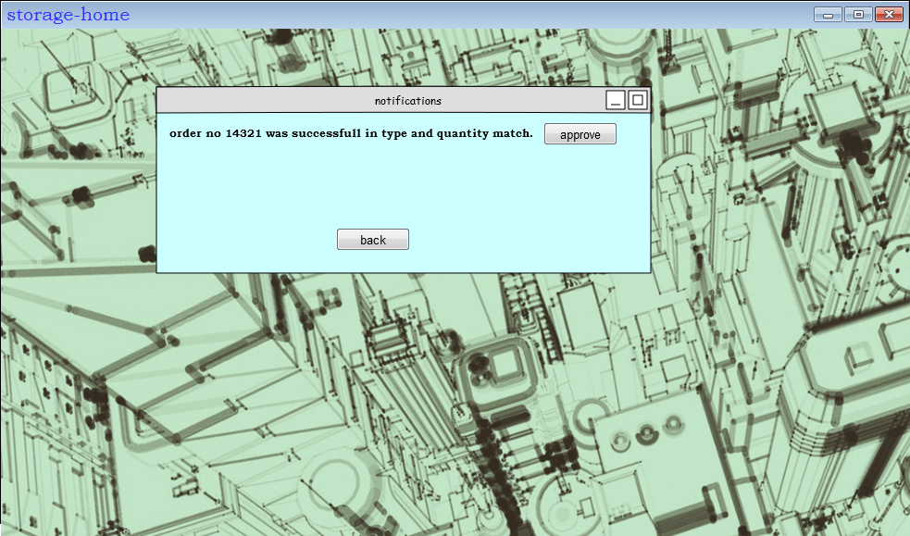

If he clicks the approve order button

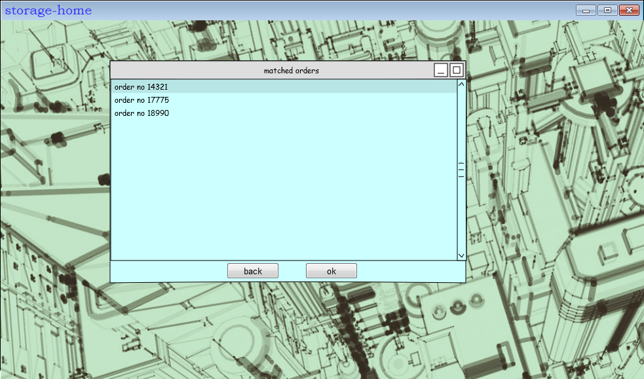

After he selects an order to approve  
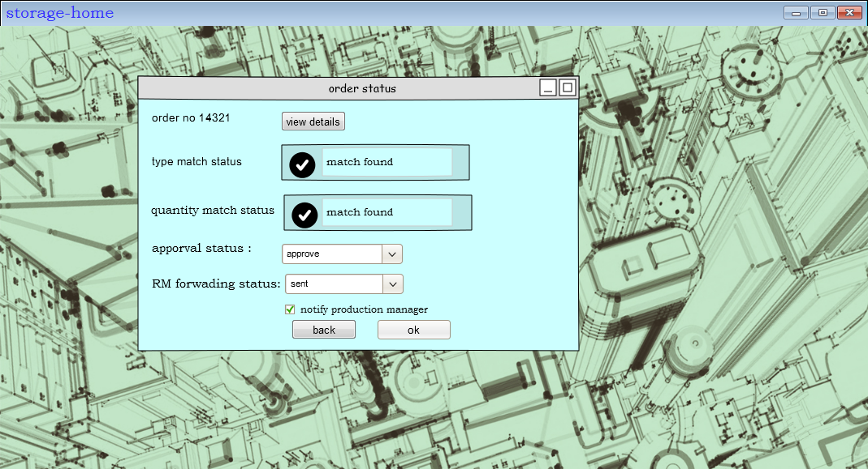

If any unauthorized user tries to access this option,i.e if the storage worker tries to approve an order, then an error message will be dispalyed  
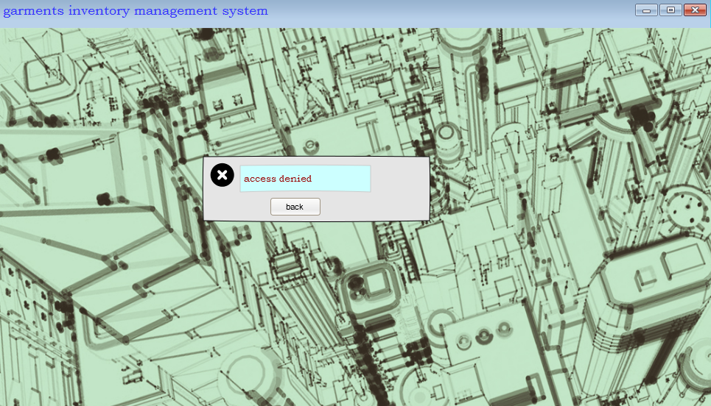

if any user from production logs in,he will see this menu  
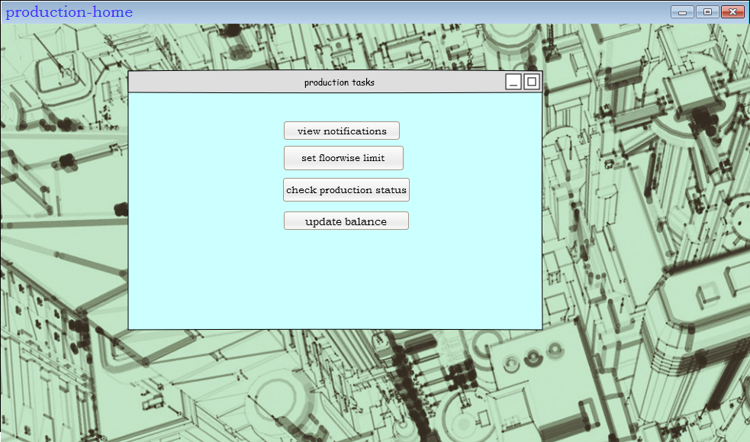  
   
the view notification option is similar to the storage section UI.

The set floorwise limit option:  
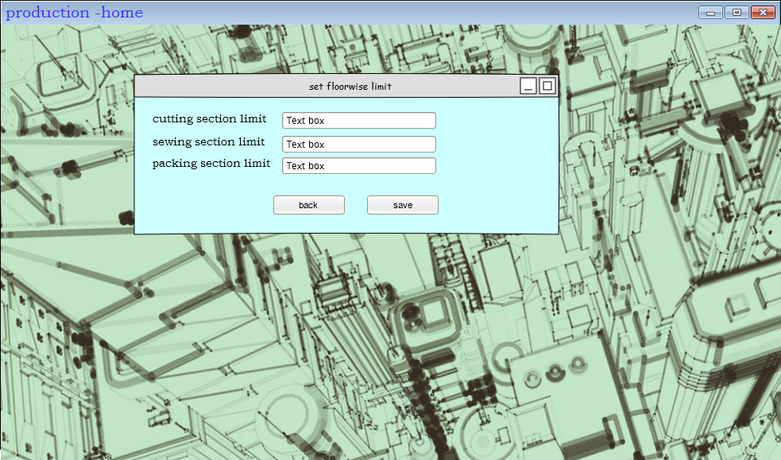

The check production status option:

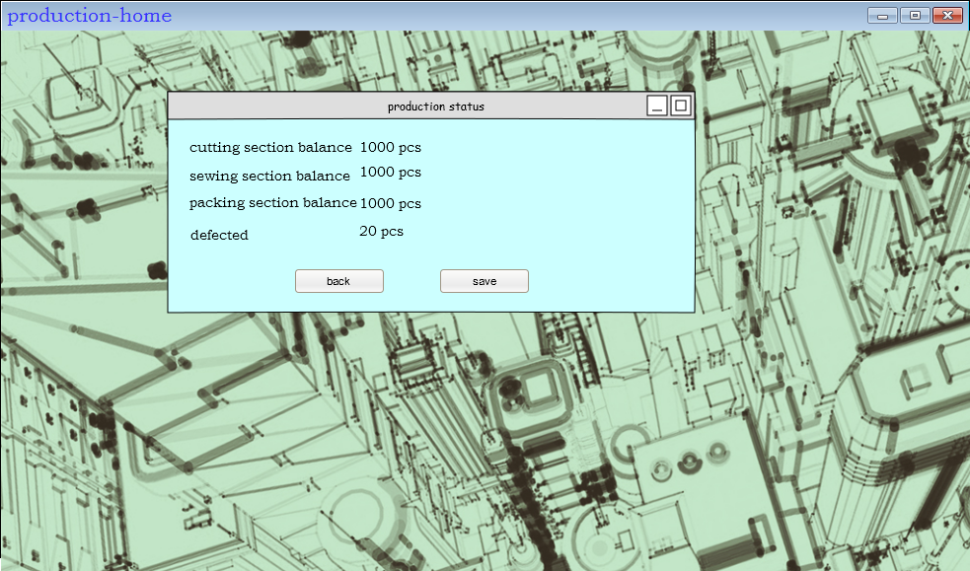

The update production status option : (accessible only for the cutting,sewing and packing section supervisor)

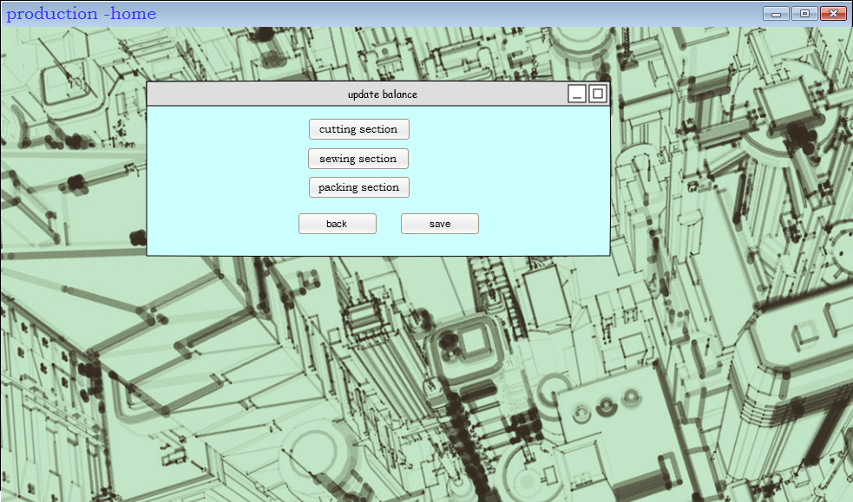

Updating the cutting section balance(accessible only by cutting section supervisor)

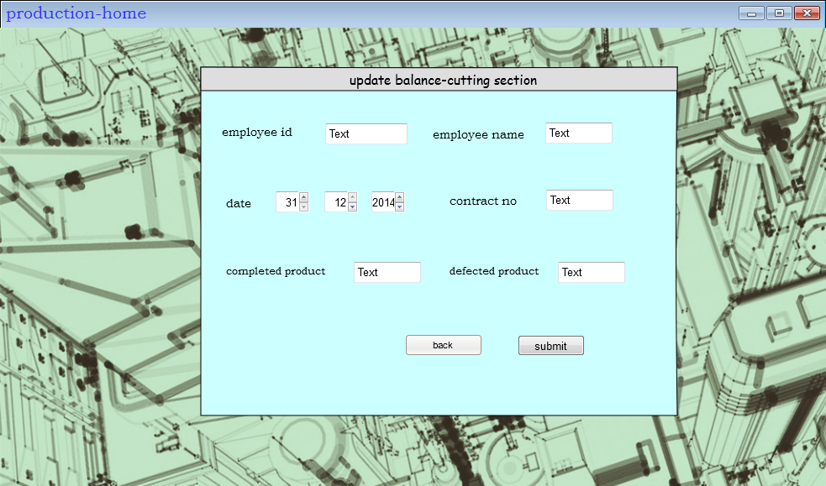

Updating the sewing section balance(accessible only by sewing section supervisor)

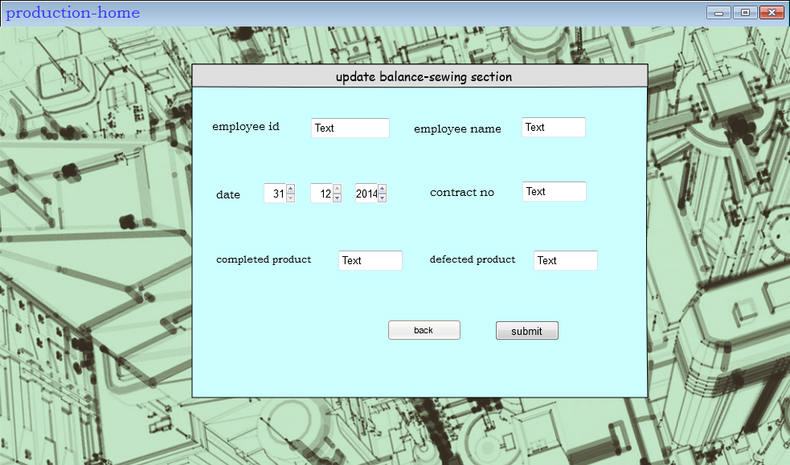

Updating the packing section balance(accessible only by packing section supervisor)

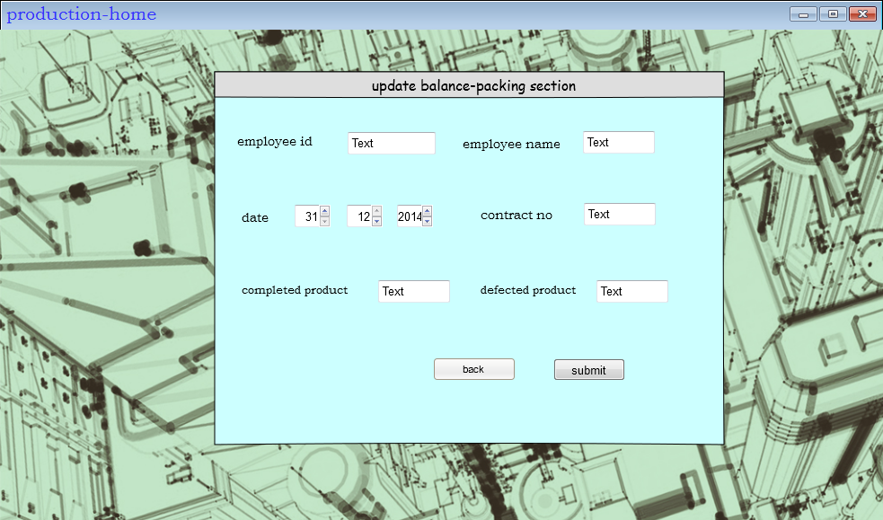

If the Balance updated successfully:  
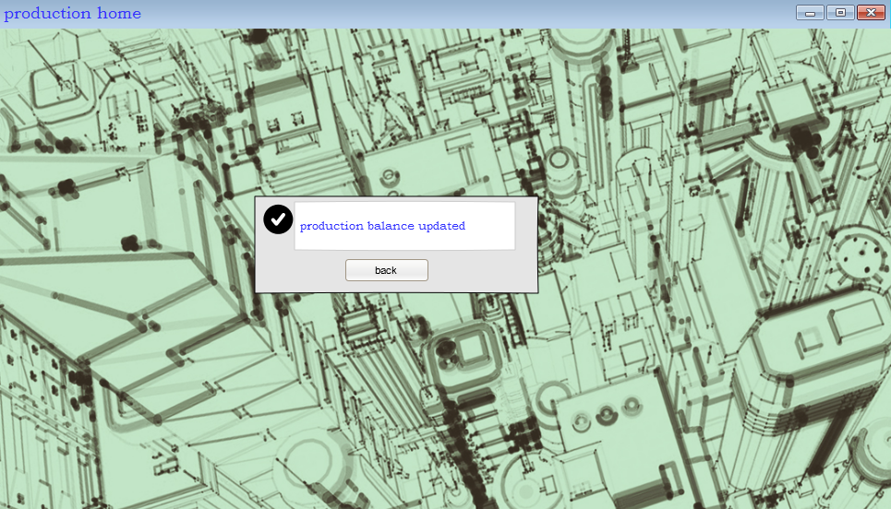

The deilvery section menu: (If the user is a delivery manager)  
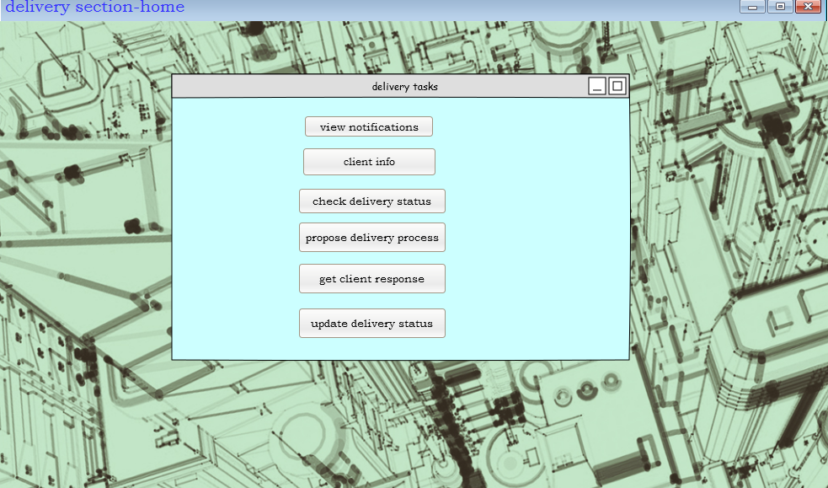

View notification is similar to storage section

If the user selects client info:

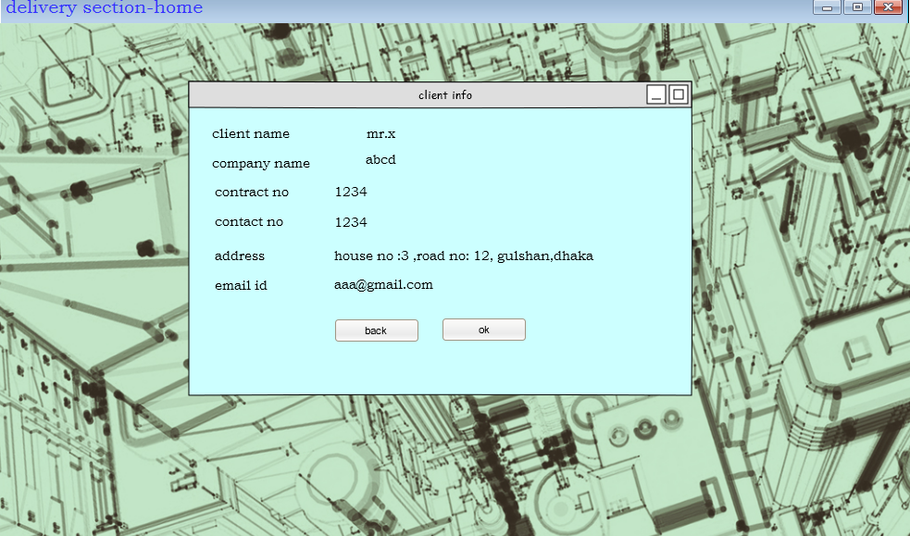

The propose delivery process option:  
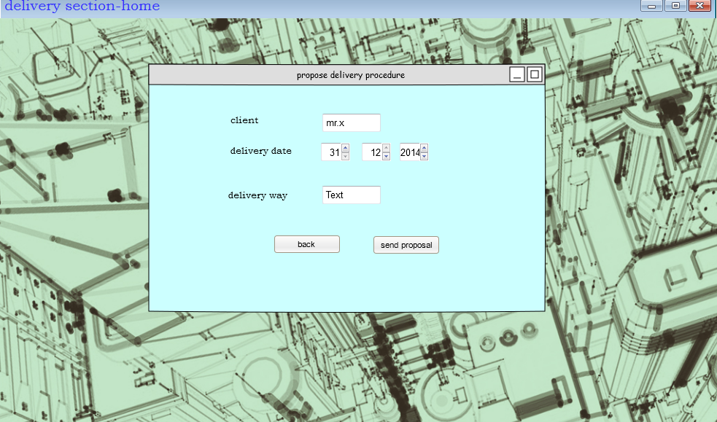

The update delivery status option:

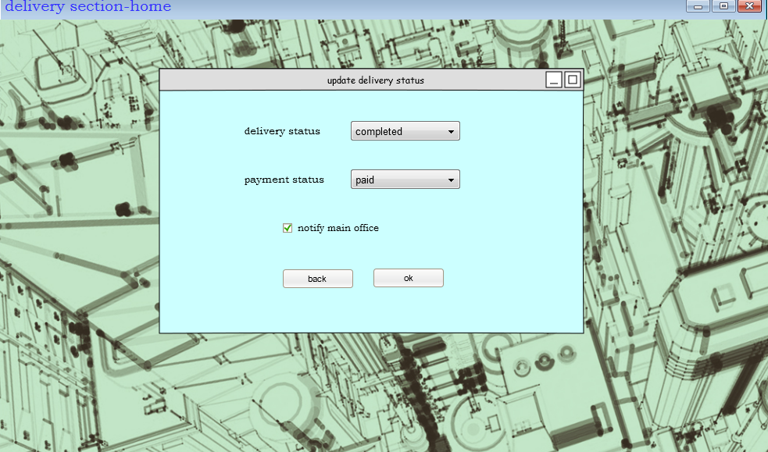

The get client response option:

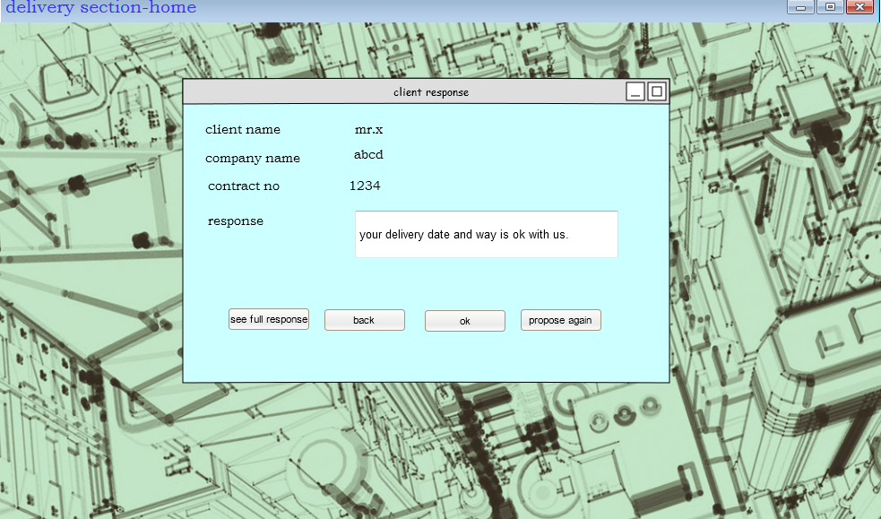

Check delivery status option:



­­­